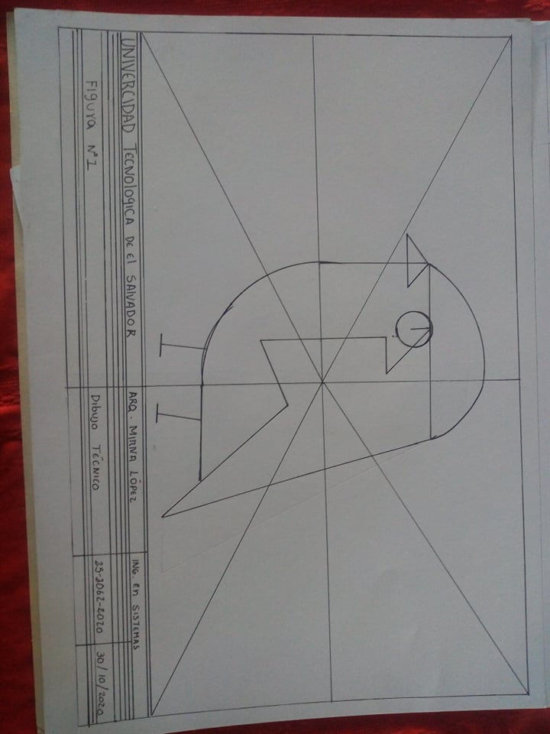

Krissia magali dueñas molina 2520622020